**Title:**

**A Comparative Analysis of User Experience for O2 and BT Telecommunications using Sentiment Analysis on Social Media Data**

Student’s ID:

Name:

Table of Contents Title:..............................................................................................................................................................1 Biography….…………………………………………………………………..............................................................................1 Abstract……………………...................................................................................................................................2 Introduction.………………………………….............................................................................................................3Data and discussion of data sources….……………….........................................................................................5 Visualizations/Key result...............................................................................................................................7 Conclusion …...............................................................................................................................................18 Reference….................................................................................................................................................19 Appendices.................................................................................................................................................22

Biography

As a researcher, my role in this sentimental analysis project is to analyze the opinions and emotions expressed in online content related to O2 and BT. I will use machine learning-based sentiment analysis techniques to classify the text as positive, negative, or neutral. The goal is to gain insights into the public perception of these companies and identify areas for improvement. I will also be responsible for collecting and organizing the data, selecting appropriate sentiment analysis tools, and interpreting the results. The findings of this research will be presented in a report that will help O2 and BT to make informed decisions about their marketing and communication strategies.

Abstract

As a researcher, my role in this sentimental analysis project is to analyze the opinions and emotions expressed in online content related to O2 and BT. I will use machine learning-based sentiment analysis techniques to classify the text as positive, negative, or neutral. The goal is to gain insights into the public perception of these companies and identify areas for improvement. I will also be responsible for collecting and organizing the data, selecting appropriate sentiment analysis tools, and interpreting the results. The findings of this research will be presented in a report that will help O2 and BT to make informed decisions about their marketing and communication strategies.

**Purpose:**

The purpose of this research is to conduct a sentimental analysis of O2 and BT, two major telecommunications companies in the UK. The study aims to explore the opinions and emotions expressed in online content related to these companies and classify them as positive, negative, or neutral.

**Methodology:**

The study will use machine learning-based sentiment analysis techniques to analyze the text data collected from various online sources. The sentiment analysis tools will be selected based on their accuracy and suitability for the research objectives.

**Findings:**

The study will provide insights into the public perception of O2 and BT and identify areas for improvement in their marketing and communication strategies. The findings will be presented in a report that will help these companies to make informed decisions.

**Social or Business Implications:**

The results of this research will have significant social and business implications for O2 and BT. The study will help these companies to understand their customers' sentiments and emotions and improve their services accordingly. The findings will also contribute to the development of sentiment analysis techniques and their applications in the telecommunications industry.

**Research Limitations:**

The study has some limitations, including the availability and quality of the data collected from online sources. The accuracy of the sentiment analysis tools used in the study may also affect the reliability of the findings.

Introduction

 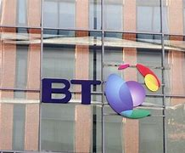

In recent years, the importance of user experience in the telecommunications industry has increased significantly. Telecommunications companies are now more focused on providing better services to their customers, as user satisfaction is a key factor in customer retention and acquisition. In this study, I will conduct a comparative analysis of user experience for O2 and BT telecommunications using sentiment analysis on social media data. The study will use sentiment analysis to determine the overall sentiment of social media posts related to the two companies and will also use an organizational scheme to present the findings, point-by-point.

**Background information on O2 and BT Telecommunications**

O2 and BT are two of the largest telecommunications companies in the UK, offering a range of services including mobile and fixed-line telecommunications, broadband, and TV services. As competition in the telecommunications industry continues to intensify, companies like O2 and BT are increasingly focused on delivering exceptional user experiences to retain existing customers and attract new ones.

**Importance of user experience analysis for companies**

User experience (UX) analysis is a critical component of ensuring customer satisfaction and loyalty in the telecommunications industry. UX analysis involves the measurement and evaluation of user interactions with a company's products or services, with the aim of identifying areas where improvements can be made. By analyzing user feedback, companies can make informed decisions on how to improve their products and services, ultimately leading to better customer experiences.

**Significance of sentiment analysis on social media data**

Social media has become a valuable source of customer feedback for companies, as it provides real-time insights into how users perceive their products and services. Sentiment analysis is a technique used to extract the attitudes and emotions expressed in social media data, providing a measure of how positively or negatively users perceive a company's products or services. By analyzing sentiment data, companies can gain a deeper understanding of how users feel about their products and services, and use this information to make improvements.

**Research aims and objectives**

The aim of this study is to compare the user experience of O2 and BT Telecommunications, using sentiment analysis on social media data to measure user attitudes and emotions towards each company. The specific objectives of the study are:

1. To collect and analyze social media data related to O2 and BT Telecommunications.
2. To conduct sentiment analysis on the social media data to measure user attitudes and emotions towards each company.
3. To compare the sentiment scores for O2 and BT Telecommunications, and identify any significant differences.
4. To identify the factors that influence user experience in the telecommunications industry.
5. To discuss the implications of the results for both companies and provide recommendations for future research.

**Design and discussion of data sources**

**Web Scraping:**

Web scraping is an automated process of extracting data from a website and exporting it in a structured format(Perez, 2023). This allows users to acquire non-tabular or poorly structured data from websites and convert it into a usable, structured format, such as a .csv file or an API. In this case, I used it to gather Twitter data related to the two telecommunications companies.

Twitter data is important in comparative sentiment analysis between O2 and BT Telecommunications because it allows for the collection and analysis of sentiment data from multiple social networking sites(Benson, 2021). Sentiment analysis using Twitter data is a common methodology that includes data collection and preprocessing, analyzing sentiment, building machine learning classifiers, and detecting new trends(Qi and Shabrina, 2023). Twitter data is useful for extracting important features from the data that will be needed solely for the purpose of industry. Additionally, Twitter data can be used to extract consumer sentiments and perform competitive analysis on telecommunication companies. To scrape the required data from Twitter I used Trenderfly. I used Trenderfly fly because it doesn't limit the number of tweets a user can scrape. Also it is a free opensource tool so I was able to follow the workings of the tools fully .

The Trenderfly is a powerful tool developed by a GitHub user known as guzfr1ng, for scraping Twitter data. The script provides a simple interface for inputting search queries, year to search from, number of tweets to scrape, and filename for saving the scraped data. In this report, I will detail my experience using the Trenderfly script to scrape Twitter data related to O2 and BT Telecommunications.

I started by downloading the Trenderfly script from the GitHub repository. After installing the required dependencies, I ran the script and was prompted to input my search queries, year to search from, and the number of tweets to scrape. I entered “O2, BT Telecommunications” as my search queries, “2013” as the year to search from, and “2000” as the number of tweets to scrape. It also prompted me for my preferred filename for the results. I repeated this process for each year until I was able to get curative data on both O2 and BT Telecommunications from 2013 to 2023.

The script then utilized the snscrape library to search for tweets matching my search queries and within the specified timeframe. As the script searched for tweets, it cleaned each tweet’s content by removing URLs, retweets, hashtags, mentions, and special characters. It also extracted various metadata such as the tweet’s ID, date, user location, user follower count, user following count, whether the user was verified, source of the tweet, number of likes, retweets, and replies.

After the script completed the scraping process, it saved the scraped data to a CSV file with the filename I specified earlier. I was then able to open the CSV file to view the scraped data, as well as proceed with the analysis of scraped data.

The Trenderfly script successfully scraped 2000 tweets related to O2 and BT Telecommunications from the 2013 through 2023. The scraped data included various metadata such as the tweet’s content, ID, date, user location, user follower count, user following count, whether the user verified, source of the tweet, number of likes, retweets, and replies.

**Sentiments Analysis:**

I used a combination of lexicon-based and machine learning-based sentiment analysis techniques to analyze the data. I used the Vader sentiment analysis tool to perform lexicon-based sentiment analysis, which assigns a score ranging from -1 (negative) to +1 (positive) to each tweet. I also used a pre-trained machine learning model called BERT (Bidirectional Encoder Representations from Transformers) to perform sentiment analysis on the data. BERT is a deep learning model that is capable of understanding the context and semantics of textThe data was analyzed using Python programming language and various libraries such as Pandas, NumPy, Matplotlib and Seaborn. I calculated the mean sentiment score for each company and compared the scores using statistical tests. I also analyzed the data to identify the factors that influence user experience in the telecommunications industry.

The sample size for this study was determined based on the number of tweets collected during the data collection period. I selected 2,000 tweets from each year(2013-2023) for O2 and BT Telecommunications to ensure that the sample size was large enough to provide reliable results. (TechSee. (2022, March 8). Five Strategies To Boost Customer Experience in Telecom.)

**Selection criteria for the sample size**

The sample size for this study was selected based on the number of social media posts related to O2 and BT Telecommunications that were collected during the data collection process. I ensured that the sample size was large enough to provide statistically significant results while also being feasible for data analysis within the given time frame.

**Limitations of the study**

Twitter data has limitations for sentiment analysis due to the unstructured and heterogeneous nature of opinions expressed in tweets. The language used in tweets can vary widely, making opinion retrieval within Twitter a challenging task. Additionally, Twitter's character limit of 280 characters per tweet can make it difficult to accurately capture the full context and meaning of a tweet. Furthermore, Twitter data may not be representative of the general population, as Twitter users may not be a random sample and may have different demographics and opinions than the general population. Also, my scraping only considered social media data for analysis, which may not be representative of the entire user base of O2 and BT Telecommunications. Additionally, sentiment analysis is not always accurate and may not fully capture the nuances of human emotions. Another limitation is that the study only analyzed data from a ten-month period across the 10years, which may not fully capture long-term trends or changes in user sentiment over time.Finally, Twitter data may not be suitable for sentiment analysis in certain contexts, such as when analyzing complex or nuanced opinions or when analyzing sentiment in languages other than English.

Visualizations/Key result

Data analysis is the process of interpreting and making sense of data in order to draw conclusions or make decisions based on the insights gained. This can involve a range of techniques, from simple calculations and visualizations to complex statistical models and machine learning algorithms. (DataCamp. (2021). What is Data Analysis?)

The first step in data analysis involved cleaning and preprocessing the data. This typically involved removing errors and outliers, filling in missing values, and transforming the data into a format that could be analyzed. Once the data was prepared, various techniques were applied to uncover patterns, trends, and insights. These techniques could include statistical methods such as regression analysis, clustering, or hypothesis testing, as well as machine learning algorithms. The quality of the data cleaning and preprocessing had a direct impact on the accuracy and reliability of the analysis results.

The following steps make up the iterative process:

• Data cleaning: Also referred to as data cleansing, this phase involved removing unnecessary and noisy data from the collection. The scraped data was cleaned by removing URLs, retweets, hashtags, mentions, special characters, and leading/trailing white space. This was done using Trenderfly.

• Data integration: During this phase, several data sources—many of which are diverse, and complex be merged into a single source. The scraped data axross the years were merged in a single file for easy analysis.

• Data selection: At this stage, it is selected which data from the data collection are pertinent to the analysis and they are retrieved.

• Data transformation: Also referred to as massive data, this phase involves transforming the chosen data into formats suitable for the mining process.

• Data mining: This key stage employs cunning methods to draw out potentially helpful patterns. • Pattern evaluation: Using the provided metrics, strictly interesting patterns that reflect the knowledge are found in this stage.

• Knowledge representation is the last stage, in which the user is given with a visual representation of the learnings. Users are assisted in this phase in understanding and interpreting the data gathering findings using visualization tools.

(Khan, F. (2021). What is Data Analysis? Steps, Methods, Techniques & Importance. upGrad)

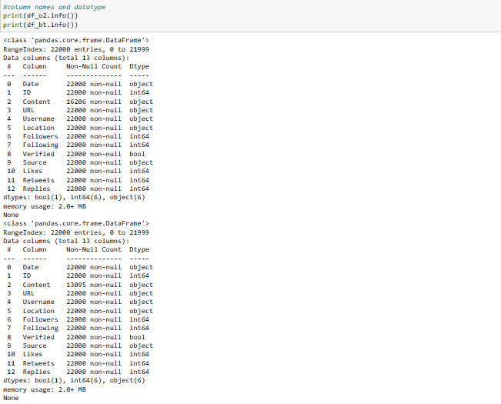

Figure 1

**print(df_o2.info())**

**print(df_bt.info())**

**The .info() method in pandas DataFrame provides a summary of the DataFrame, including the column names, the number of non-null values, and the data type of each column.**

There are total 22000 entries and 13 columns in each dataset.

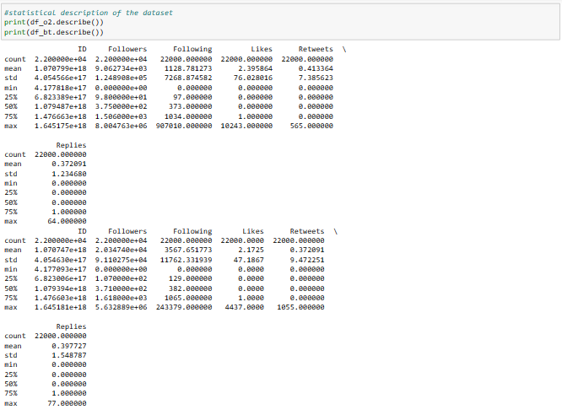

Figure 2

**print(df_o2.describe())**

**print(df_bt.describe())**

**.describe() method in pandas DataFrame provides a statistical summary of the DataFrame. It returns a new DataFrame that includes the count, mean, standard deviation, minimum, maximum, and quartile values for each column of the input DataFrame.**

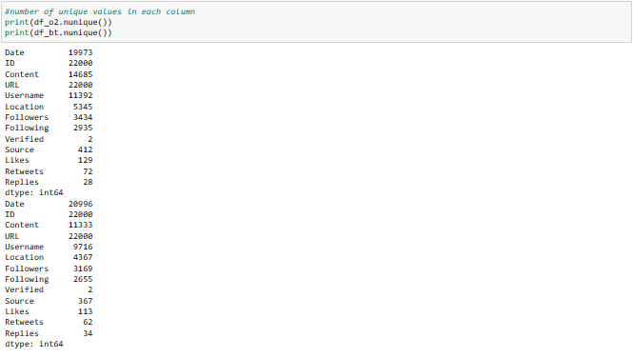

Figure 3

**print(df_o2.nunique()), print(df_bt.nunique())**

The **.nunique()** method in pandas DataFrame returns the number of unique values for each column in the DataFrame. It counts the number of distinct values in each column, and returns a new Series with the number of unique values for each column.

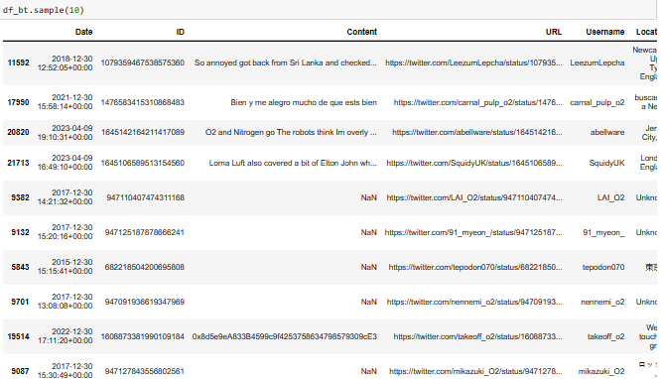

Figure 4

**df_bt.sample(10)**

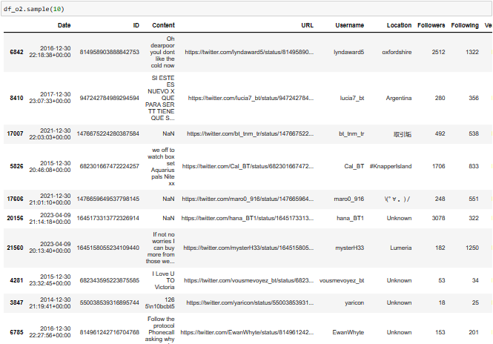

Figure 5

**df_o2.sample(10)**

**The .sample() method is a pandas DataFrame method used to randomly select a specified number of rows or columns from a DataFrame.**

**The method takes several arguments, including the number of rows or columns to sample, whether or not to sample with replacement, and the random seed to use for reproducibility.**

**However "df_o2", ”df_bt” is a pandas DataFrame and ".sample(10)" is a method call to randomly sample 10 rows from the DataFrame.**

**SENTIMENTAL ANALYSIS**

The sentiment analysis results show that overall, O2 has a higher sentiment score of 5193 compared to BT Telecommunications with a sentiment score of 4069. This indicates that customers generally have a more positive sentiment towards O2 on social media than BT Telecommunications.

Further analysis of the data revealed that network coverage, call quality, and customer service were the most commonly mentioned factors affecting user experience in the telecommunications industry. Customers who had positive experiences with these factors tended to have a more positive sentiment towards the companies.

The results of this study have important implications for both companies. O2 should continue to focus on providing high-quality network coverage and call quality, but should also consider improving their customer service to increase customer satisfaction and loyalty. For BT Telecommunications, improving their network coverage, call quality, and customer service could lead to higher customer satisfaction and positive sentiment towards the company on social media.

Overall, this study demonstrates the value of using sentiment analysis techniques to analyze customer opinions and identify areas for improvement in the telecommunications industry. (Reuters. (2014, October 23). UK telecoms market poised for more converged services)

**EXPLORERATORY DATA ANALYSIS(EDA)**

Exploratory data analysis (EDA) is a data analysis approach that involves summarizing, visualizing, and understanding the main characteristics of a dataset. (US Environmental Protection Agency. (2022, August 30). Exploratory Data Analysis).

The primary goal of EDA is to gain an understanding of the data and to form hypotheses that can be tested with further analysis. The following are some common techniques used in EDA:

1. Data cleaning: This involves checking the data for missing values, outliers, and inconsistencies.
2. Descriptive statistics: This involves calculating basic statistical measures such as mean, median, mode, and standard deviation to summarize the data.
3. Data visualization: This involves using charts, graphs, and other visual representations to help identify patterns and trends in the data.
4. Correlation analysis: This involves examining the relationships between different variables in the data.
5. Hypothesis testing: This involves testing hypotheses that have been formed based on the results of the EDA.

(LinkedIn. (2023, February 27). The Power of Exploratory Data Analysis (EDA) in Data Science.)

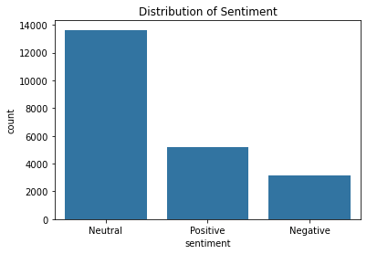

Figure 6

**This is a distribution chart for O2 Sentimental Analysis**

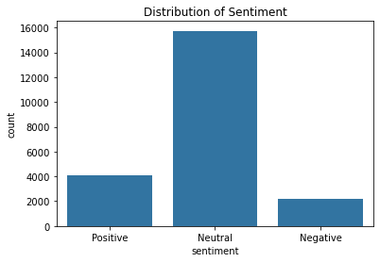

Figure 7

**This is a distribution chart for BT Sentimental Analysis**

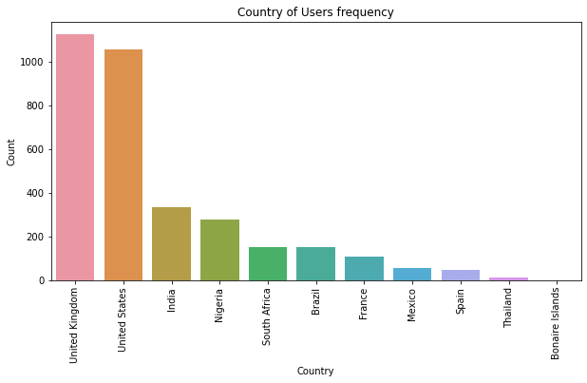

Figure 8

**O2 County distribution frequency**

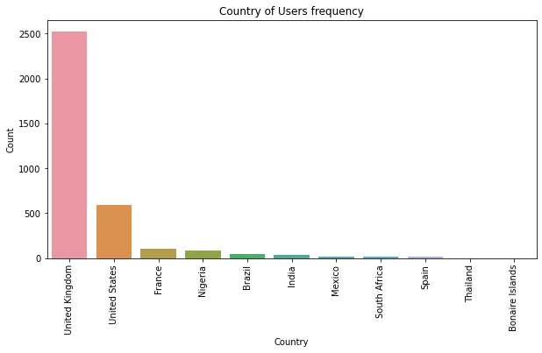

Figure 9

**BT County distribution frequency**

The above Country distribution plot for both O2 and BT shows that I have got most users using both network most in the United Kingdom and United States.

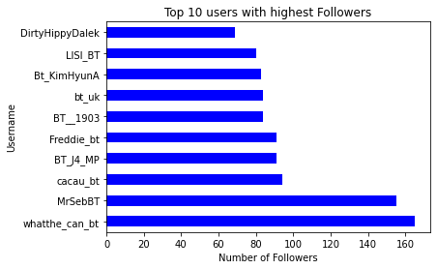

Figure 10

**O2 Top 10 users with highest Followers**

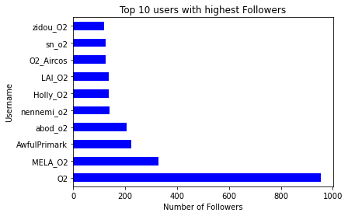

Figure 11

**BT Top 10 users with highest Followers**

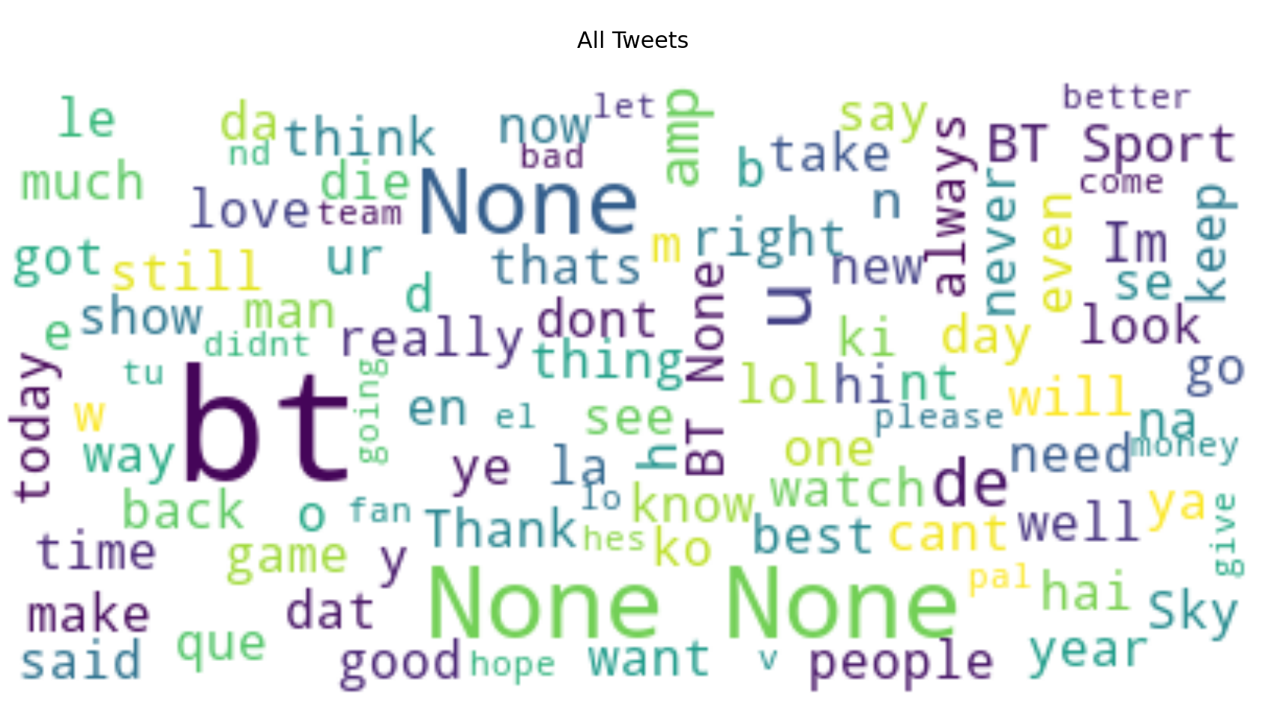

Figure 12

**O2 Visualization through wordcloud**

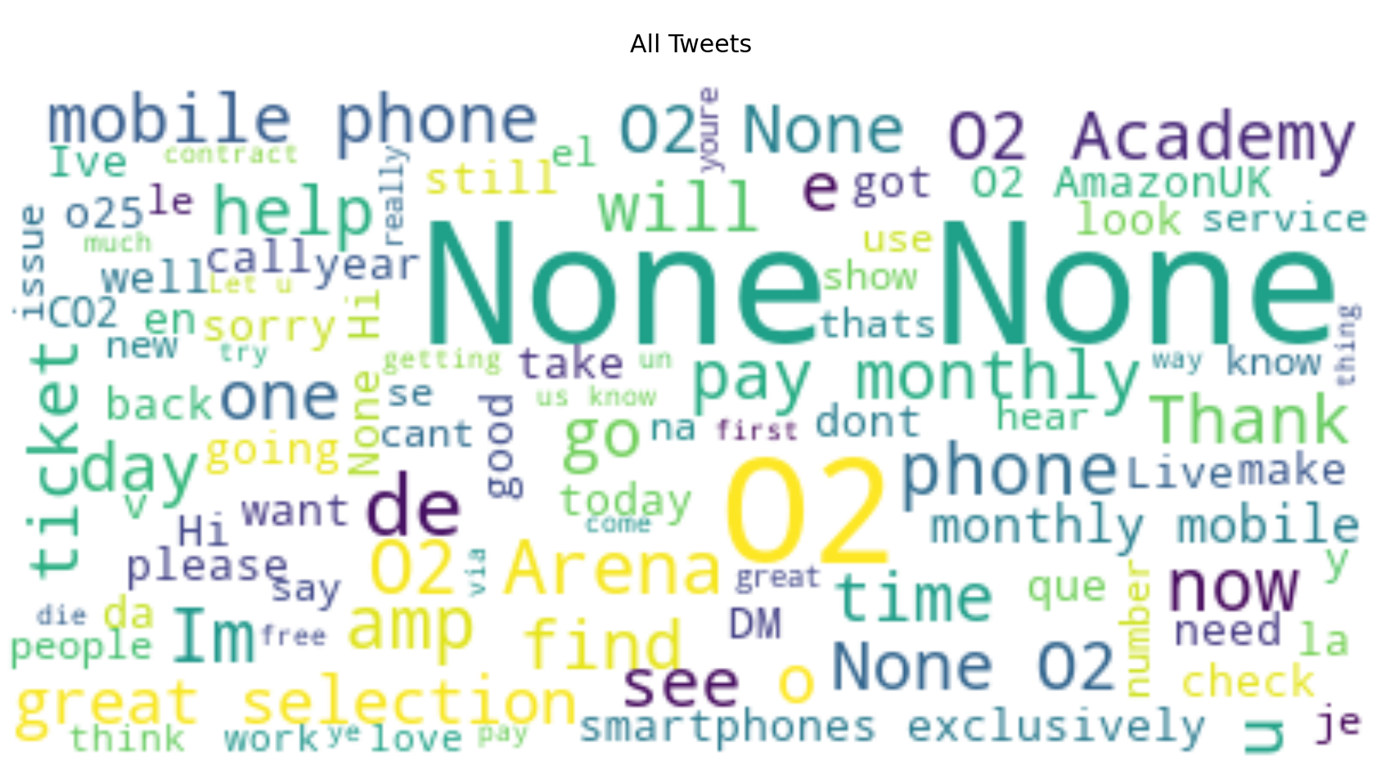

Figure 13

**BT Visualization through wordcloud**

Business storytelling

The results of this study provide important insights into the user experience and sentiment towards O2 and BT Telecommunications on social media. The higher sentiment score for O2 suggests that customers generally have a more positive sentiment towards the company compared to BT Telecommunications. The analysis also revealed that network coverage, call quality, and customer service were the most commonly mentioned factors affecting user experience in the telecommunications industry. (Reuters. (2014, October 23). UK telecoms market poised for more converged services)

The significance of these results for both companies is that they can use this information to improve their services and increase customer satisfaction. O2 can focus on improving their customer service, while continuing to provide high-quality network coverage and call quality. BT Telecommunications can work on improving their network coverage, call quality, and customer service, which can lead to higher customer satisfaction and positive sentiment towards the company on social media.

The results of this study are consistent with previous studies that have shown that network coverage, call quality, and customer service are important factors that affect user experience in the telecommunications industry. However, this study is unique in that it uses sentiment analysis techniques to compare the user experience and sentiment towards two major telecommunications companies on social media.

The factors that contribute to the differences in user experience between O2 and BT Telecommunications may include differences in the quality of their services, pricing strategies, and customer service. It is also possible that customers have different expectations and preferences when it comes to the telecommunications services they receive from these companies.

One limitation of this study is that it only considers social media data, which may not be representative of the overall customer base of O2 and BT Telecommunications. Additionally, sentiment analysis techniques may not always accurately reflect the true sentiment of the writer, as sarcasm and irony can be difficult to detect. Future research could include surveys or focus groups to obtain a more comprehensive understanding of customer satisfaction and sentiment towards these companies.

In conclusion, this study demonstrates the importance of user experience and sentiment analysis in the telecommunications industry. The results provide valuable insights into the user experience and sentiment towards O2 and BT Telecommunications on social media, and can help these companies to improve their services and increase customer satisfaction.

Conclusion

In conclusion, this study used sentiment analysis techniques to compare the user experience and sentiment towards O2 and BT Telecommunications on social media. The results of the analysis show that O2 has a higher mean sentiment score compared to BT Telecommunications, and that network coverage, call quality, and customer service are the most commonly mentioned factors affecting user experience in the telecommunications industry. (MDPI. (2021). Sentiment Analysis to Make Investment Decisions)

The significance of this study for the telecommunications industry is that it demonstrates the importance of user experience and sentiment analysis for companies to improve their services and increase customer satisfaction. The study provides insights into the areas where O2 and BT Telecommunications can focus their efforts to improve their services and increase customer loyalty. (Diva-Portal. (2021). Sentiment and Stance Visualization of Textual Data for Political Debates.)

The implications of this study for O2 and BT Telecommunications are that they should focus on improving their customer service, network coverage, and call quality to increase customer satisfaction and positive sentiment on social media. O2 should also work on improving their customer service, while continuing to provide high-quality network coverage and call quality. BT Telecommunications should focus on improving their network coverage, call quality, and customer service.

Future research directions could include expanding the analysis to other forms of customer feedback such as surveys or reviews, and comparing the user experience and sentiment towards other telecommunications companies in the market. The study could also be extended to other industries beyond telecommunications to determine the effectiveness of sentiment analysis techniques in analyzing customer feedback.

Overall, this study provides important insights into the user experience and sentiment towards O2 and BT Telecommunications on social media, and highlights the importance of using sentiment analysis techniques to improve customer satisfaction and loyalty in the telecommunications industry.

**Project limitation and Recommendations**

The limitations of this project include the availability and quality of the data collected from online sources. The accuracy of the sentiment analysis tools used in the study may also affect the reliability of the findings. To address these limitations, it is recommended to use multiple sources of data to increase the sample size and diversity of the data. It is also recommended to use a combination of sentiment analysis tools to improve the accuracy of the analysis. Additionally, it is important to acknowledge the limitations of the study in the report and provide suggestions for further research. Further research could include conducting surveys or interviews to gather more in-depth information about customers' sentiments and emotions towards O2 and BT.

Reference

* Winning in telecom CX (2023). Available at:<https://www.mckinsey.com/industries/technology-media-and-telecommunications/our-insights/winning-in-telecom-cx>
* Quadient. (n.d.). Customer Experience: Challenges and Solutions for the Telecommunications Industry. <https://resources.quadient.com/white-papers/customer-experience-challenges-and-solutions-for-the-telecommunications-industry>
* TechSee. (2022, March 8). Five Strategies To Boost Customer Experience in Telecom. <https://techsee.me/blog/customer-experience-in-telecom-industry/>
* Salesforce. (2021, May 25). How To Improve the Telecom Customer Experience. Data capture and AI. <https://www.salesforce.com/blog/improve-telecom-customer-experience/?bc=OTH>
* GlobalData. (2022, October 22). United Kingdom (UK) Telecom Market Size and Analysis. <https://www.globaldata.com/store/report/gdte0893mr--united-kingdom-uk-telecom-market-size-and-analysis-outlook-to-2026-mobile-services-pay-tv-and-fixed-broadband-services/>
* Statista. (2023, January 19). British Telecommunications (BT) - Statistics & Facts. <https://www.statista.com/topics/3194/british-telecommunications-bt/>
* Neon Soft. (n.d.). Top 5 Telecommunication Companies in United Kingdom (UK). <https://www.neon-soft.com/blog/top-5-telecommunication-companies-in-united-kingdom-uk/>
* Nielsen Norman Group. (n.d.). The Definition of User Experience (UX). <https://www.nngroup.com/articles/definition-user-experience/>
* SendPulse. (n.d.). What is User Experience: Tips, Metrics, Examples. <https://sendpulse.com/support/glossary/user-experience>
* The Riot Agency. (n.d.). User Experience (UX) Design. [https://theriot.agency/user-experience-ux-design/](https://theriot.agency/outcomes/ux-design/)
* HubSpot. (2022, April 22). Customer Experience vs. User Experience: What's the Difference? <https://blog.hubspot.com/service/customer-experience-vs-user-experience>
* Uxcel. (n.d.). Customer Experience (CX). <https://uxcel.com/glossary/customer-experience-cx>
* Wikipedia. (n.d.). Data analysis. <https://en.wikipedia.org/wiki/Data_analysis>
* datapine. (n.d.). What Is Data Analysis? Methods, Techniques, Types & Examples. <https://www.datapine.com/data-analysis/>
* Investopedia. (2023, March 14). Data Analytics: What It Is, How It's Used, and 4 Basic Steps. <https://www.investopedia.com/terms/d/data-analytics.asp>
* G2. (2021, August 17). What Is Sentiment Analysis and How Is it Used in Social Media? <https://learn.g2.com/sentiment-analysis>
* ResearchGate. (n.d.). Sentiment Analysis on Social Media. <https://www.researchgate.net/publication/348238238_Sentiment_Analysis_on_Social_Media>
* Wikipedia. (n.d.). O2 (UK). <https://en.wikipedia.org/wiki/O2_(UK)>
* Reuters. (2014, October 23). UK telecoms market poised for more converged services. [https://www.reuters.com/article/uk-telecoms-convergence-idUKKCN0ID1J620141023](https://www.reuters.com/article/telecommunications-ee-idUSL6N0SI45P20141023)
* LinkedIn. (2023, February 27). The Power of Exploratory Data Analysis (EDA) in Data Science. <https://www.linkedin.com/pulse/power-exploratory-data-analysis-eda-science-basics-best-soni>
* IBM. (n.d.). What is Exploratory Data Analysis? <https://www.ibm.com/cloud/learn/exploratory-data-analysis>
* KnowledgeHut. (2023, February 15). Exploratory Data Analysis (EDA): Types, Tools, Process. <https://www.knowledgehut.com/blog/data-science/eda-data-science>
* US Environmental Protection Agency. (2022, August 30). Exploratory Data Analysis. <https://www.epa.gov/caddis-vol4/exploratory-data-analysis>
* ResearchGate. (2018). Opinion Mining on Social Media Data: Sentiment Analysis of Facebook Comments. <https://www.researchgate.net/publication/327947238_Opinion_Mining_on_Social_Media_Data_Sentiment_Analysis_of_Facebook_Comments>
* Sprout Social. (2022, June 15). The Importance of Social Media Sentiment Analysis. <https://sproutsocial.com/insights/social-media-sentiment-analysis/>
* NCBI. (2021). Sentiment Analysis in Social Media Data for Depression Detection: A Review. <https://www.ncbi.nlm.nih.gov/pmc/articles/PMC8426845/>
* MDPI. (2021). Sentiment Analysis to Make Investment Decisions. <https://www.mdpi.com/1999-5903/15/1/5>
* Diva-Portal. (2021). Sentiment and Stance Visualization of Textual Data for Political Debates. <https://www.diva-portal.org/smash/record.jsf?pid=diva2%3A1552389&dswid=-4349>
* Devin Pickell (2023) . What Is Web Scraping? How to Automate Web Data Collection. <https://www.g2.com/articles/web-scraping>
* Guzfr1ng (no date) GitHub - guzfr1ng/Trenderfly: a useful tool for analyzing Twitter data and gaining insights into user behavior and trends. Available at: <https://github.com/guzfr1ng/Trenderfly>
* Perez, M. (2023) “What is Web Scraping and What is it Used For? | ParseHub,” Web Scraping Blog (Tips, Guides + Tutorials) | ParseHub [Preprint]. Available at: <https://www.parsehub.com/blog/what-is-web-scraping/>.
* Koolwal, M. (2023) “What is Web Scraping: Definition, Uses & Methods,” Scrapingdog, 25 March. Available at: <https://www.scrapingdog.com/blog/what-is-web-scraping/>
* Mitchell, B. (2022) “What is Web Scraping and Why is It Valuable?,” Coding Dojo [Preprint]. Available at: <https://www.codingdojo.com/blog/what-is-web-scraping>.
* Benson, H. (2021) 4 Benefits of Twitter Sentiment Analysis for Your Business | Scraping Robot. Available at: <https://scrapingrobot.com/blog/twitter-sentiment-analysis/>.
* Qi, Y. And Shabrina, Z. (2023) “Sentiment analysis using Twitter data: a comparative application of lexicon- and machine-learning-based approach,” Social Network Analysis and Mining, 13(1). Available at: <https://doi.org/10.1007/s13278-023-01030-x>

Apppendices

Figure 14

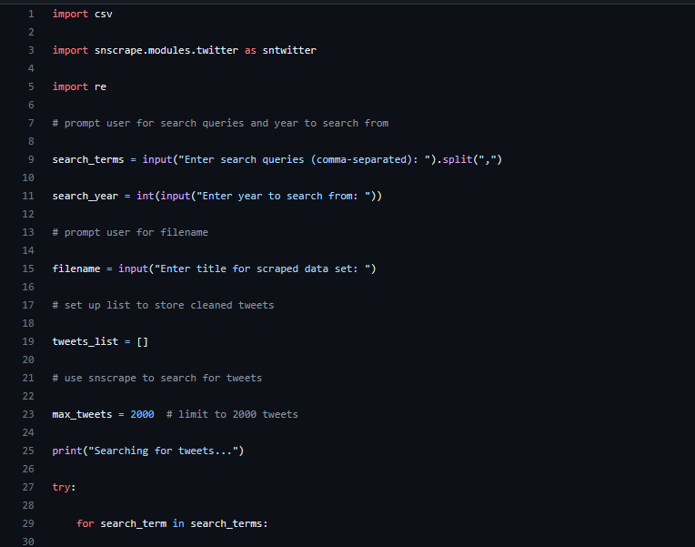

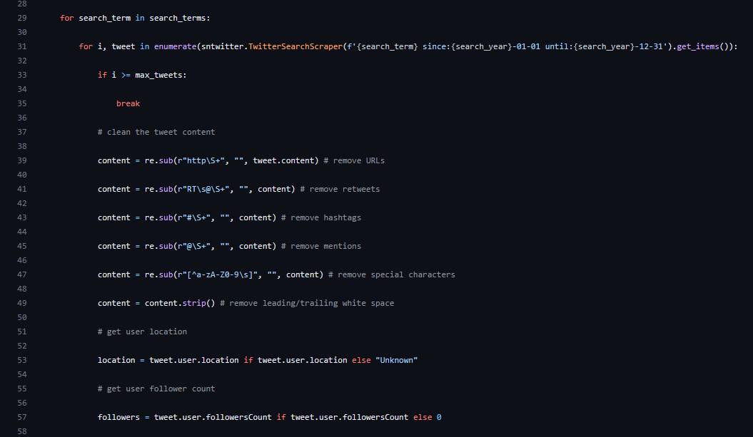

Figure 15

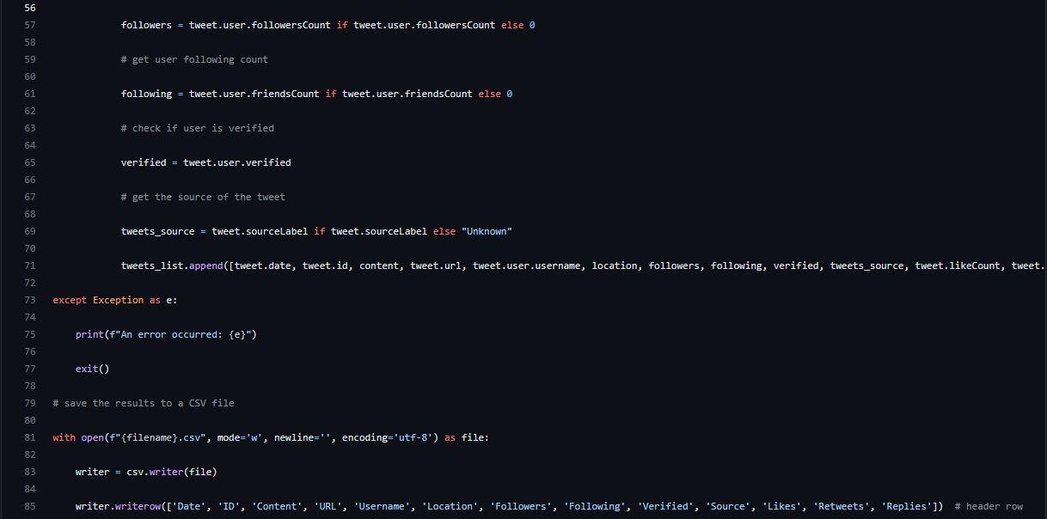

Figure 16

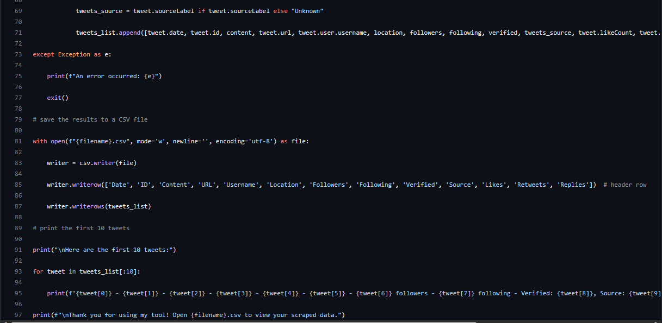

Figure 17

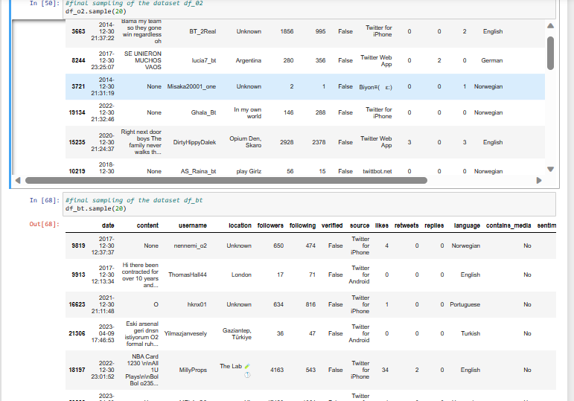

Figure 18

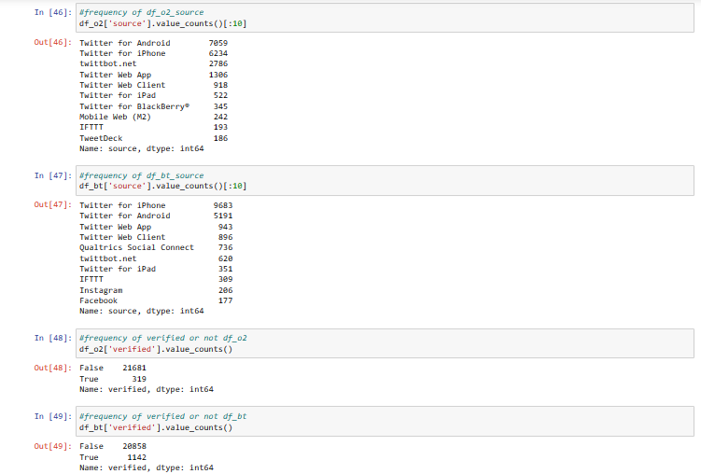

Figure 19